**1.INTRODUCTION**

*1*.*1* *Overview*

A vehicle that can be powered by an electric motor that draws electricity from a battery and is capable of being charged from an external source and have an electric motor instead of an internal combustion engine.

The Electric Vehicle (EV) is not new, but it has been receiving significantly more attention in recent years Advances in both EV analytics and battery technologies have led to increased automotive market share. However, this growth is not attributed to hardware alone. The modern mechatronic vehicle marries electrical storage and propulsion systems with electronic sensors, controls, and actuators, integrated closely with software secure data transfer, and data analysis, to form a comprehensive transportation solution. Advances in all these areas have contributed to the overall rise of EV’s but the common thread that runs through all these elements is data analytics.

The new EV’s are combined Electrical storage and propulsion systems with electronic sensors, controls, and actuators, integrated closely with software, secure data transfer to form a comprehensive transportation solution.

1.2 Purpose

In this project used to analysis the different vehicle charge capacity.

Used to point out the charging station.

**2.PROBLEM DEFINTION AND DESIGN THINKING**

2.1 Empathy map

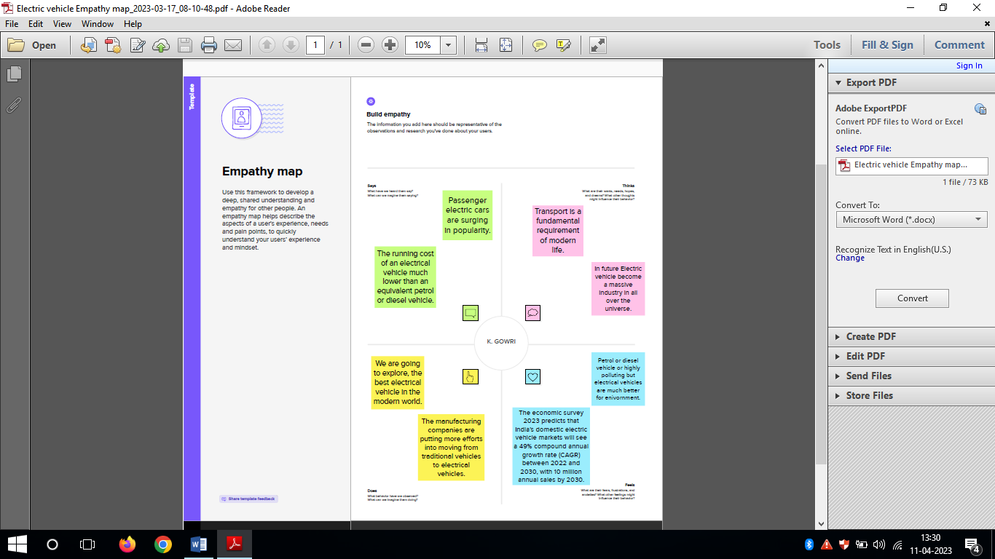

2.2 Ideation & Brainstorming Map

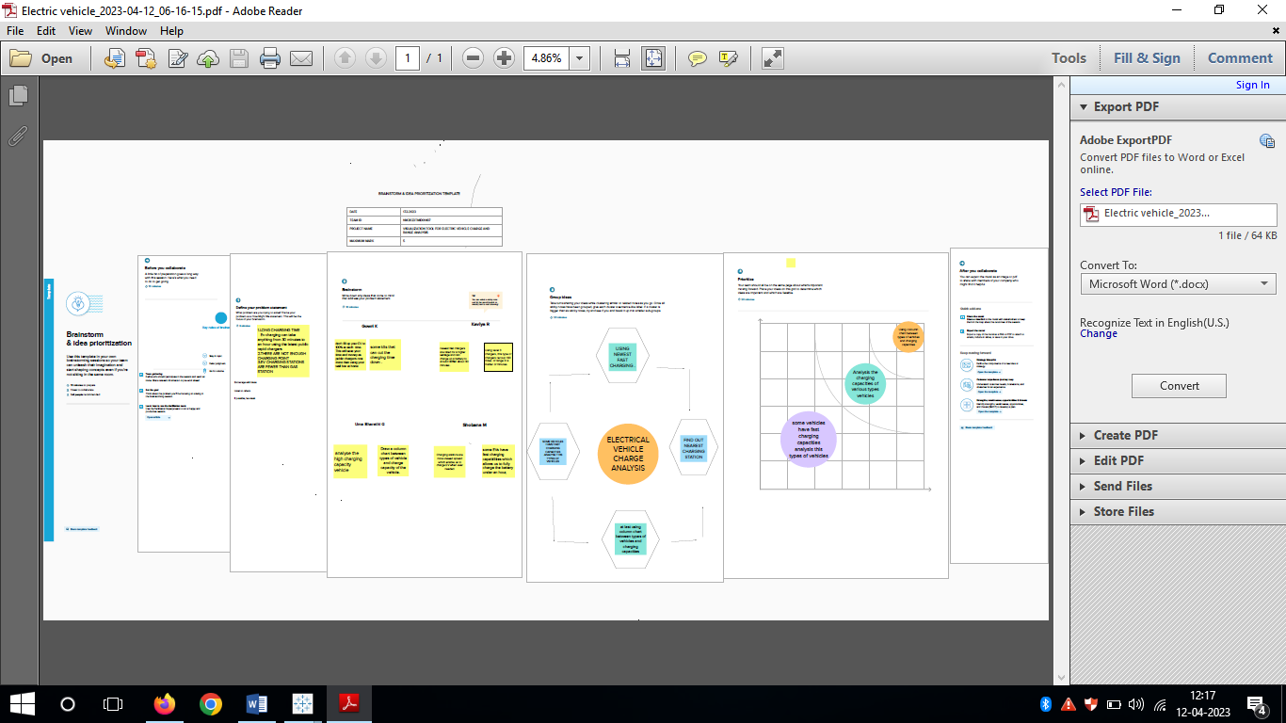

**3.RESULT**

**Dashboard** **1**

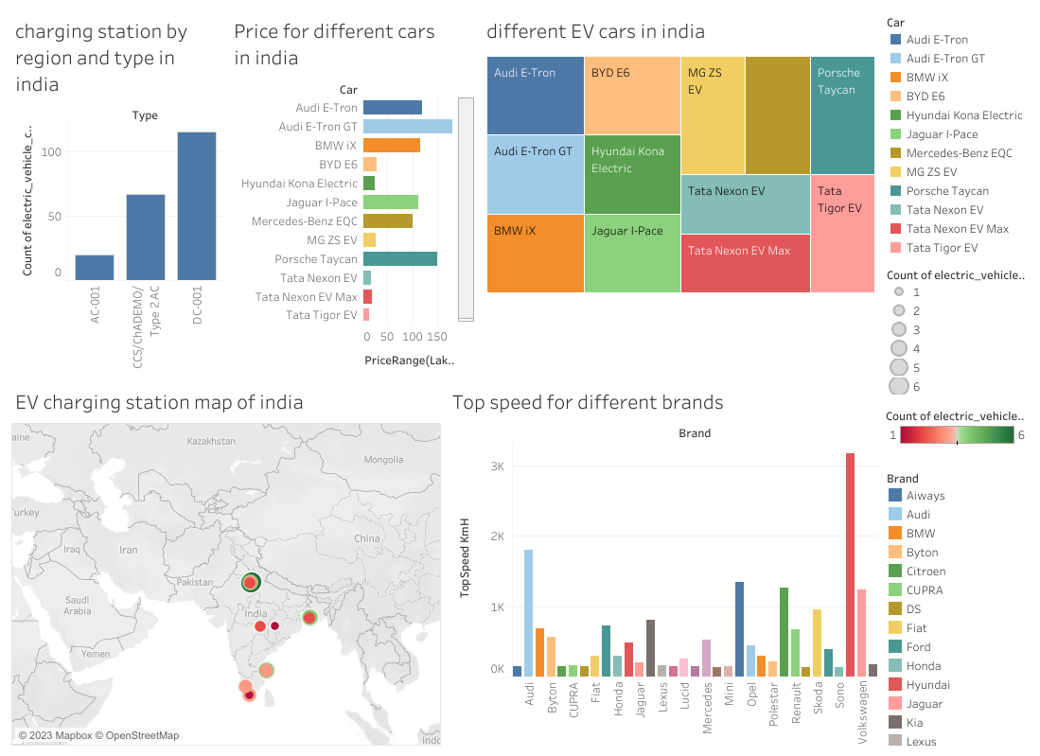

**Dashboard** **2**

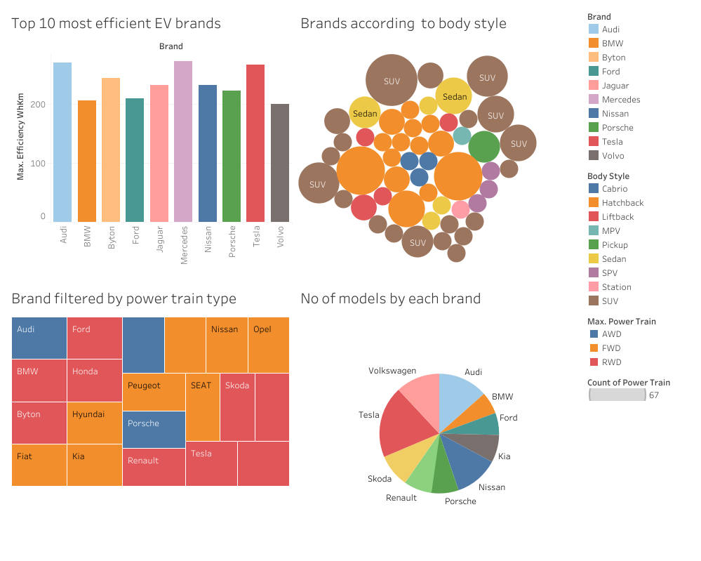

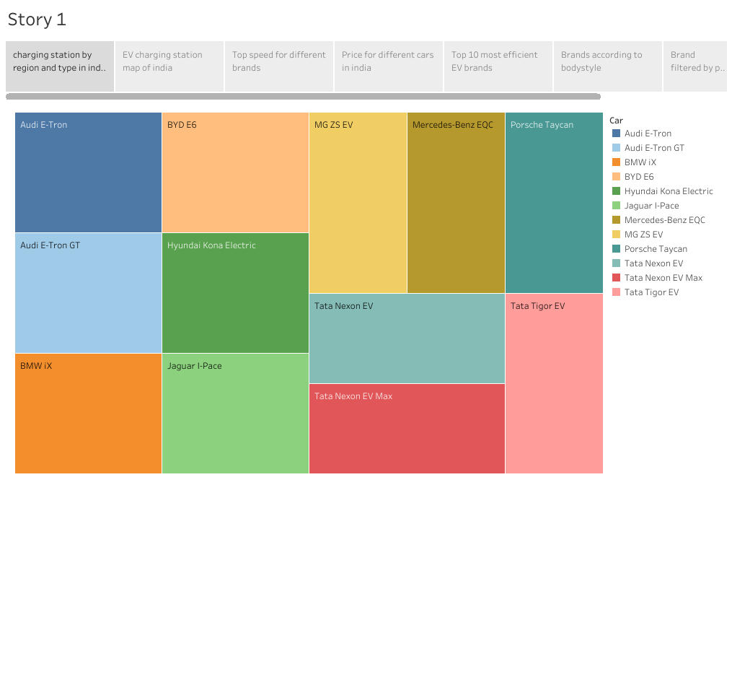

**Web** **Intergrated**

**Using** **sublime**



**4. ADVANTAGES AND DISADVANTAGES**

***Advantages***

1. Eco friendly
2. Renewable energy source
3. Less noise and smoother motion
4. Cost effective
5. Low maintenance
6. Government support

***Disadvantages***

1. High initial cost
2. Charging station limitations
3. Recharging takes time
4. Limited options
5. Less driving range

**5. APPLICATION**

1. Electrical vehicle suited for high ways.

2. Personal transportation

3. Fleet transportation

4. Delivery and courier service

**6. CONCLUSION**

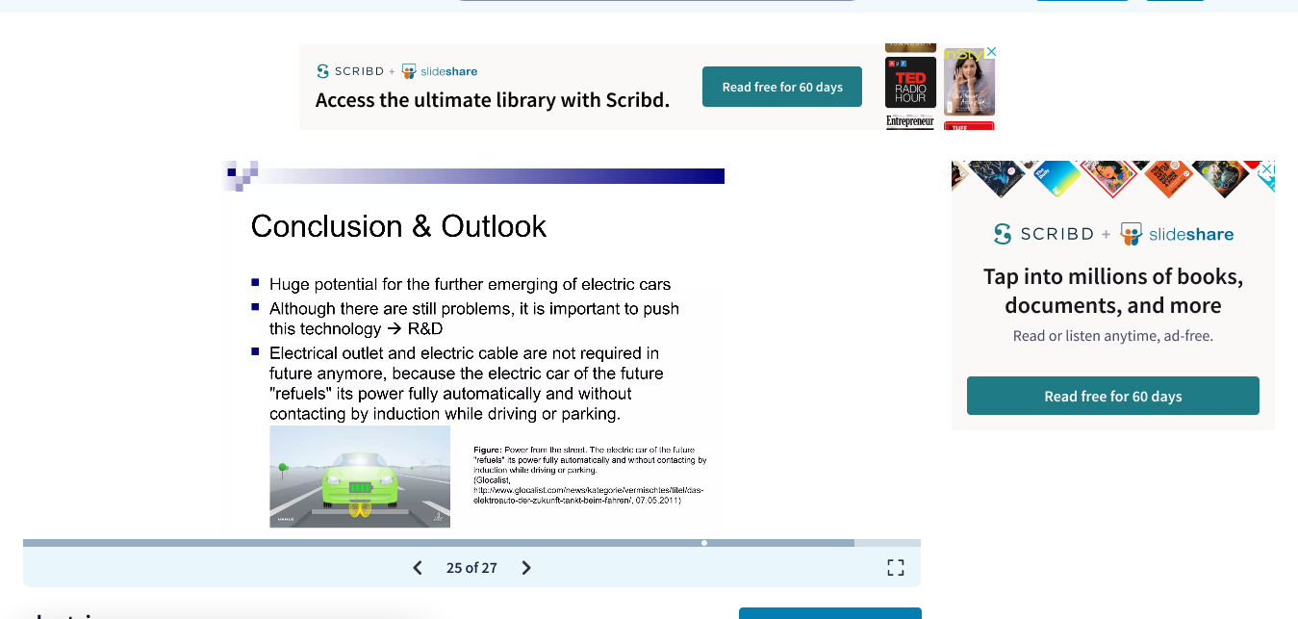

**7.FUTURE SCOPE**

1. More incentives, tax cuts, and rebates should be given to the vehicle purchasers along with the stockholders.

2. More spending on R&D

3. Phasing out the ICE vehicles

4. Creating proper infrastructure

5. Several drives to make people conscious of the benefits of using EVs

**8. APPENDIX**

A. Source code

